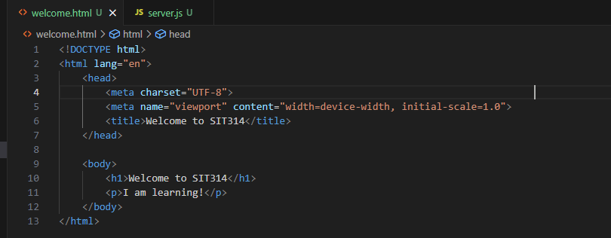
Picture 1 – Code of ‘welcome.html’
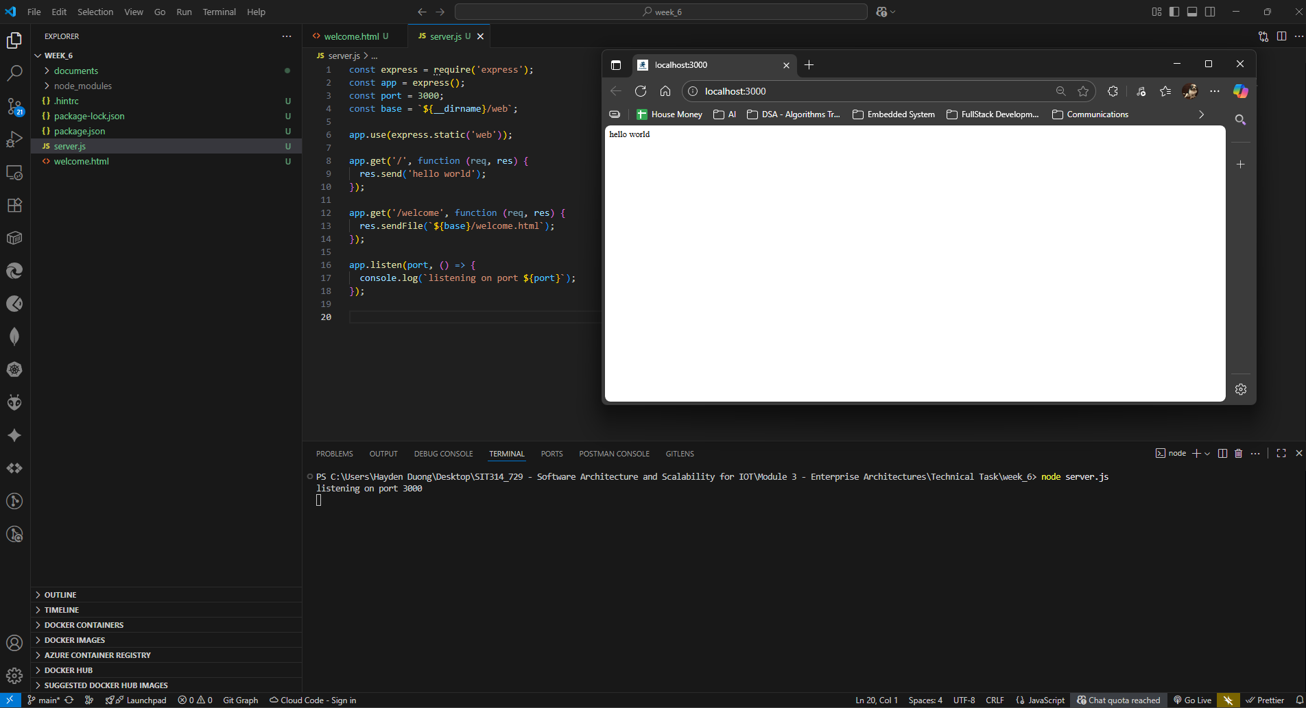
Picture 2 – Code of ‘server.js’ & result from running ‘node server.js’
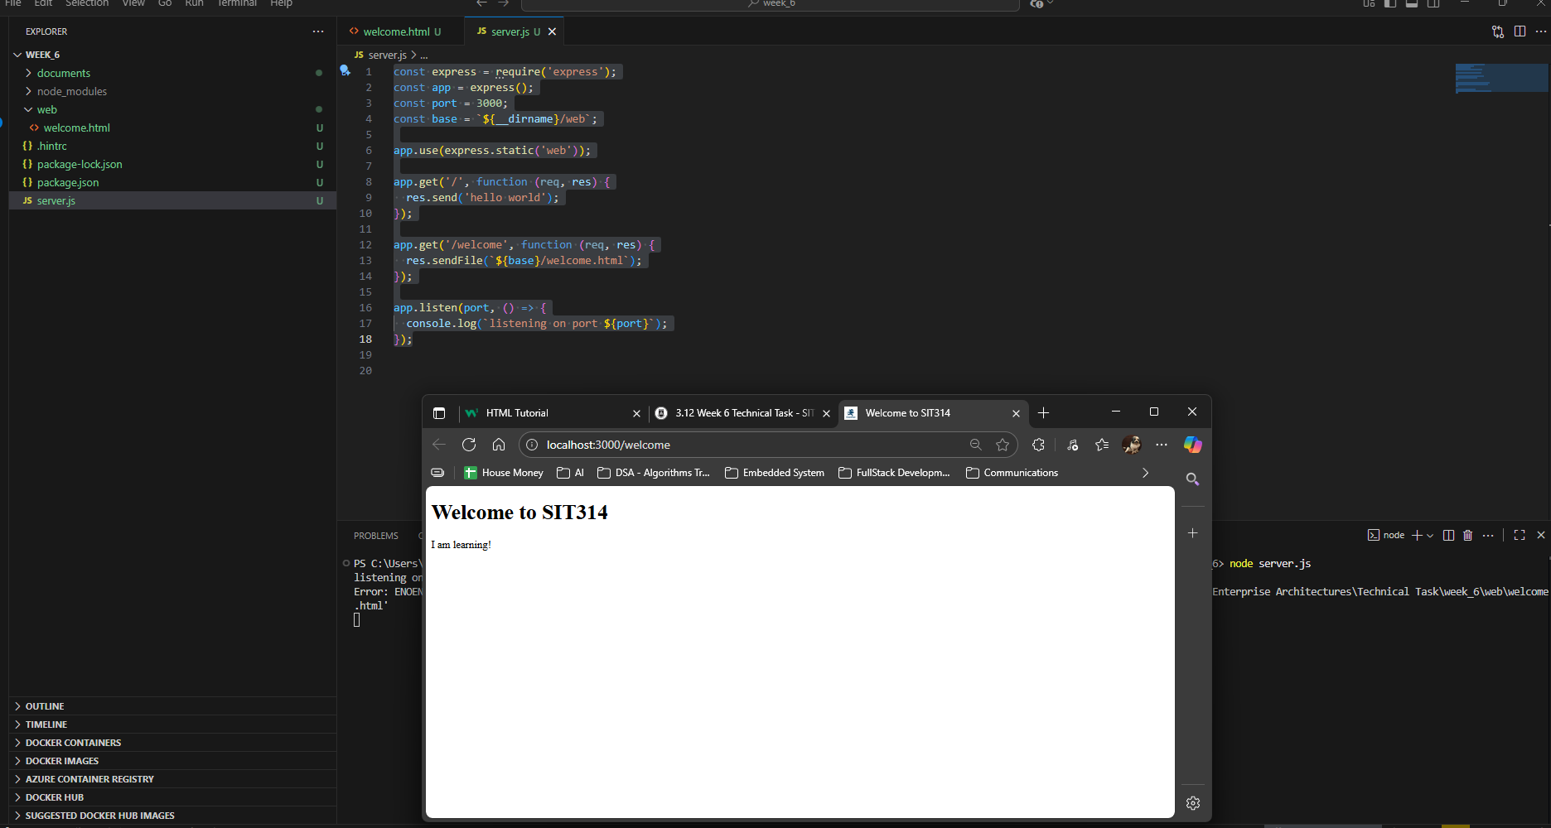
Picture 3 – Successfully displayed the ‘/welcome’
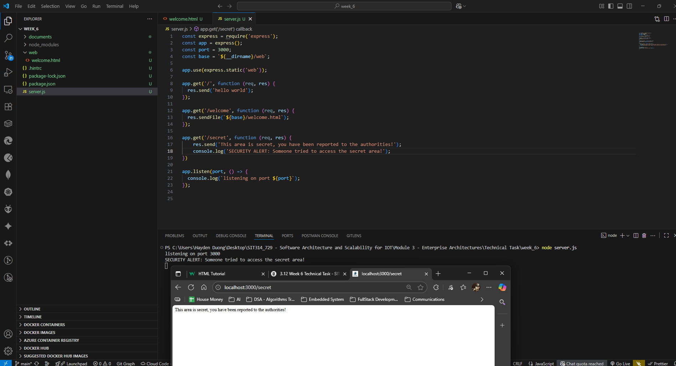
Picture 4 - Successfully displayed the result from ‘/secret’

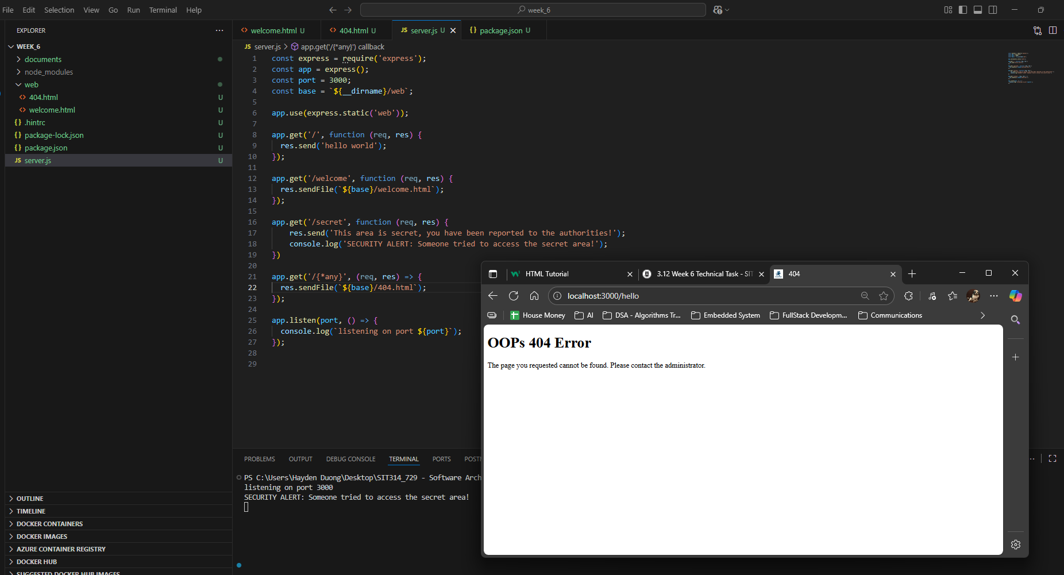
Picture 5 - Successfully displayed the result from ‘/{*any}’

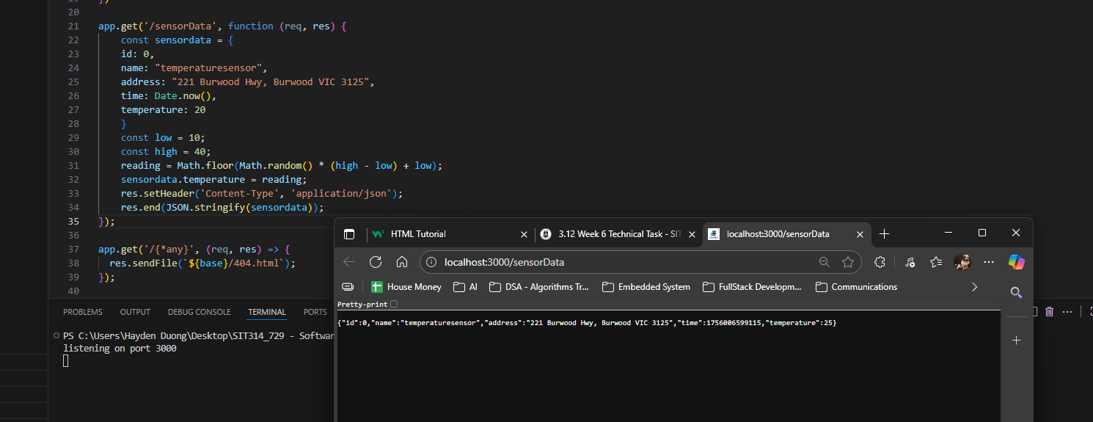
Picture 6 - Successfully displayed the result from ‘/sensorData’

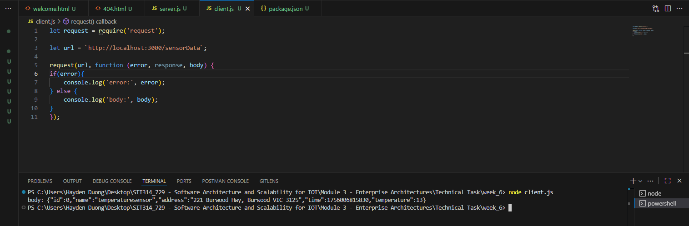
Picture 7 - Successfully displayed the result from ‘node client.js’

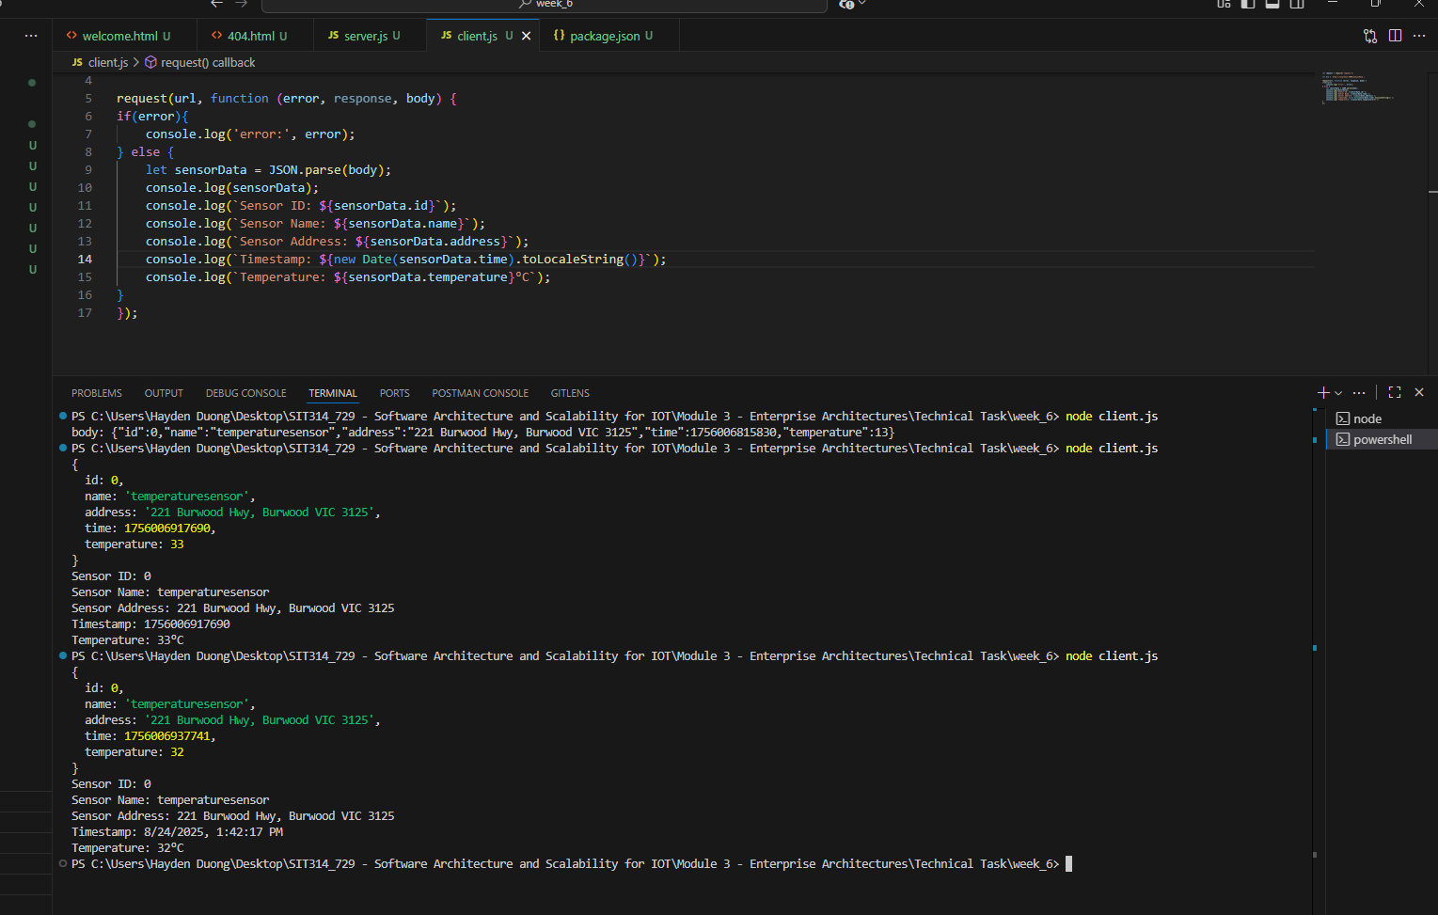
Picture 8 - Successfully displayed the result from modified ‘client.js’

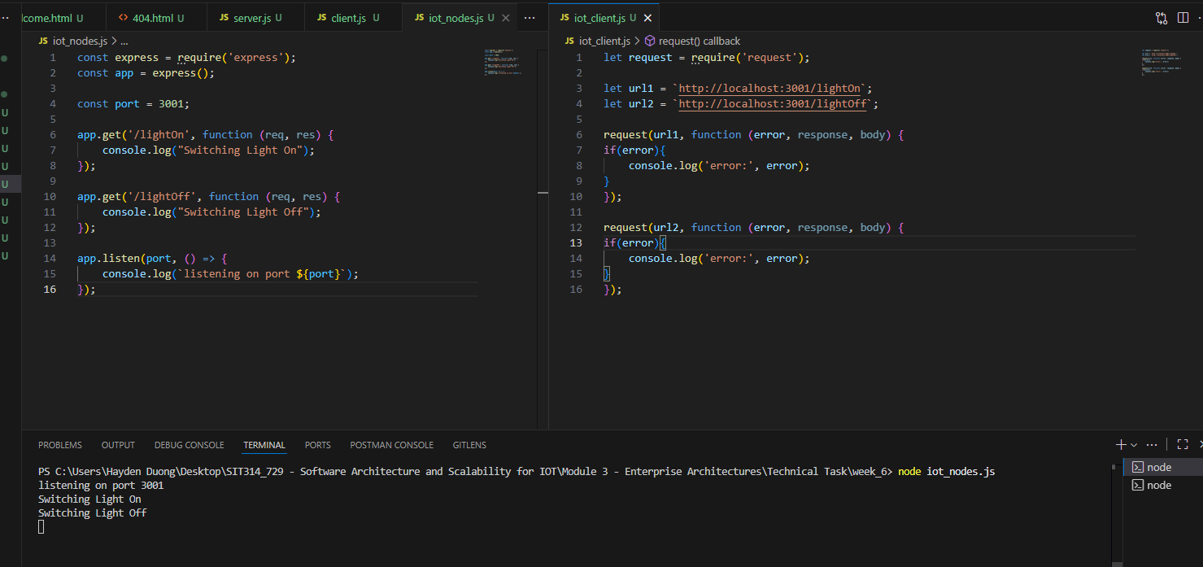
Picture 9 - Successfully displayed the results from task 6c

